Task No & Title:  Unit 1 | Unit Descriptor Unit Descriptor This unit covers the skills and knowledge required to work effectively within a commercial or business environment. It includes identifying the rights and responsibilities of employees and employers and conducting business in accordance with the organizational goals, values and standards.
Title: | BSBCMN201A Work effectively in a business environment
Suitable for Classes: | Certificate II Business
Area: | Technology & Enterprise
Teacher: | Mr Peter Faulks
Timeline | 1 Lesson
Date Due: | Today

Task Brief:

Files Required

Items highlighted in yellow are tasks for you to complete
Items in Purple are help tips

Unit | Number | Title | Study Time
1 | BSBCMN201A | Work effectively in a business environment | 20
2 | BSBCMN202A | Organize and complete daily work activities | 15
3 | BSBCMN203A | Communicate in the workplace | 30
4 | BSBCMN204A | Work effectively with others | 20
5 | BSBCMN205A | Use business technology | 30
6 | BSBCMN211A | Participate in workplace safety procedures | 15
7 | BSBCMN213A | Produce simple word processed documents | 40
8 | BSBCMN214A | Create and use simple spreadsheets | 20
9 | BSBCMN108A | Develop keyboard skills | 40
10 | BSBCMN107A | Operate a Personal Computer | 20
11 | ICAITU013C | Integrate Commercial computer packages | 30
12 | ICAITU012C | Design Organizational Documents using computer | 50
 |  | TOTAL

Work effectively in a business environment

1.1 Identify and read organisation’s requirements and responsibilities and seek advice from appropriate persons, where necessary
1.2 Develop and utilise a current working knowledge and understanding of employee and employer rights and responsibilities
1.3 Comply with relevant duty of care, legal responsibilities and organisational goals and objectives
1.4 Identify roles and responsibilities of colleagues and immediate supervisors
1.5 Identify standards and values considered detrimental to the organisation and communicate this through appropriate channels
1.6 Identify, recognise and followbehaviour contributing to a safe work environment
2 Work in a team
2.1 Display courteous and helpful manners at all times
2.2 Complete allocated tasks
2.3 Seek assistance when difficulties arise
2.4 Use questioning techniques to clarify instructions or responsibilities
2.5 Identify and display a non-discriminatory attitude in all engagements with staff, management or clients
3 Develop effective work habits
3.1 Identify work and personal priorities and achieve a work/life balance
3.2 Apply time management strategies to work duties
3.3 Observe appropriate dress and behaviour as required by job role

How to write a Job Application

Use an advertisement from below; find a general position being offered. You may bring an advert from the local newspaper if you wish.

Write a letter applying for the position providing personal details and your opinion as to why you would be suitable for the position offered.

Overview: In today's job market you are in serious competition. For every position that is available in any chosen field, there are numerous job candidates that are equally qualified. This means that you are going to have to sell yourself in a big way in a matter of just seconds. How, you may ask? On your application letter and resume, that's how! Now is the time to get started preparing your application letter and resume. Be sure it is both accurate and appealing to the eye. It is the first impression that a prospective employer will have of you. Therefore, it must be perfect!

Purpose: To be able to write and format an application letter and resume in preparation for a successful job search.

Objectives:

1. The students will be able to describe what should be included in an application letter and resume.
2. The students will complete the Resume Worksheet
3. The students will organize and format their application letter and resume.

Choose one of the advertised positions (below) from a local newspaper, and write a letter of application for the position. Check that you have:

* understood the key words in the advertisement ( where is the job, what sort of job is it and what experience or qualifications do you need?);
* set out your letter like the model;
* sent it to the right person;
* included all the stages of the letter;
* used accurate spelling and punctuation;
* checked the language features.
Model Letter

From?????
123 Desperate Street
Hopeful WA 6000

The Personnel Officer
Secure Guards Ltd
320 The High Street
Perth WA 6000

20/6/00

Dear sir,

I am applying for the post of Security Guard advertised in "The West Australian" yesterday and I am enclosing a copy of my CV as requested.

As you can see, I have worked for five years as the Prime Minister’s personal bodyguard and before that I was in the army. My commanding officer and the Prime Minister can both supply you with references and their addresses can be found on my CV.

My experience in the army included working in Northern Ireland and the Falklands. I have also accompanied the Prime Minister on his overseas trips. I notice that the advertised vacancy involves working overseas and I am very keen on travelling, which is why I have chosen to apply for this post.

I hope you will give my application serious consideration and I look forward to hearing from you.

Yours faithfully,

Richard Strong

Richard Strong

How not to write the letter

HOW NOT TO WRITE A FORMAL LETTER!

There are grammar mistakes, spelling mistakes, punctuation mistakes, mistakes in the order of the paragraphs, and also mistakes in the lay-out. Work in pairs and see how many you can find!

19 avenue road
Badbman wa 6123

Majestic Hotel
Hyatt hoitel
Perth wa 6000

The nineteenth of January

dear Julia Rambert,

I am interesting in the job of Waitress advertised on "Radio" this morning and I am enclosing a copy of my CV.

I hope you will consider my application carefuly and I look forward to hear from you.

I am working as waitress in my own country since five years before I came here and my former employer can provide you with a referee.

I imagine that you cater mainly for overseas tourists so I belief my language skills would be usefull. In addition to speak both portuguese and english, I also can understand spanish.

yours faithfully,

Maria Chagas

Maria Chagas

Positions 1 Choose any
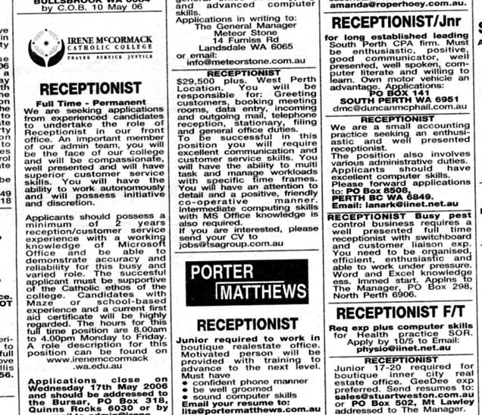

Positions 2 Choose any
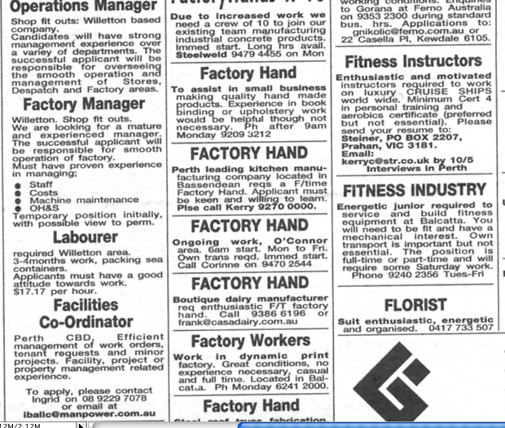

Positions 3 Choose any

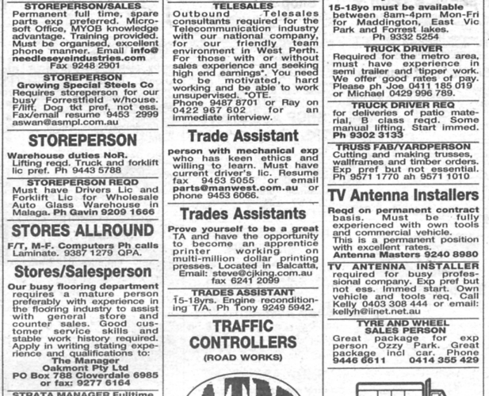

Positions 4 Choose any

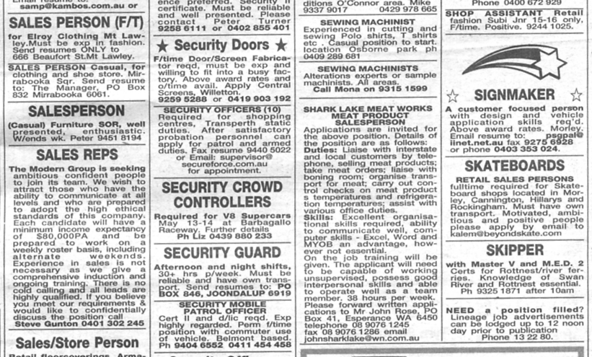


Save the work

